Seamless Database

Current Connection Information
Database management address: http://vps.975e509ca1.hostnet-vps.nl/phpmyadmin/
Username: admin
Password: SeamlessAdmin2022
Database IP address: 185.57.8.99

Server Setup
First, you will need to download and install Putty in order to connect to the virtual Linux machine: https://www.putty.org/

You can open a connection by entering the IP address of the database into Host Address and clicking open.
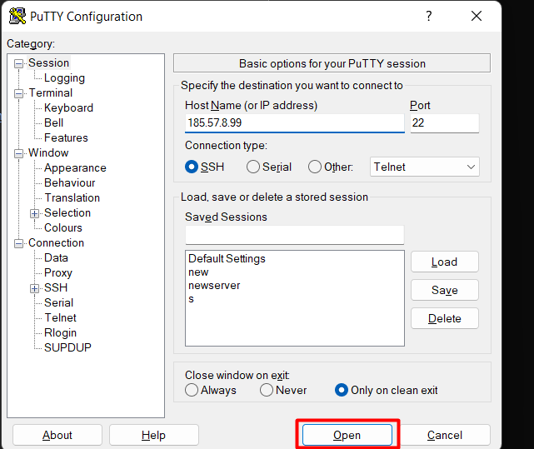
You will now see a terminal window where you can log in (login info provided above, if you have a new server you will need to use the default root user and password provided to you by the webhost)
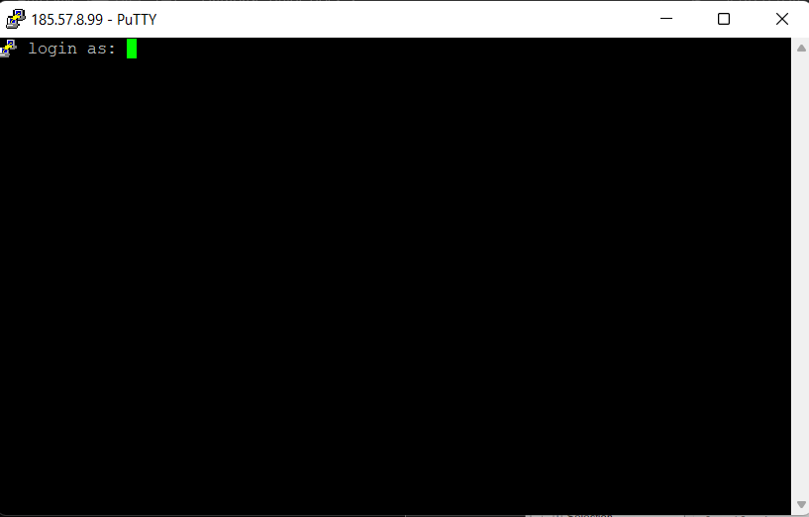
You will need to use the terminal to install LAMP stack and phpMyAdmin, follow the instructions here: https://www.linuxtechi.com/install-phpmyadmin-linux/
The database settings can be configured manually in the file my.cnf file usually located at /etc/mysql/my.cnf, which you can open with nano. It is a text file where you change the values and save the file.

Database Setup

The easiest way to do this is:
- Go to phpMyAdmin (currently http://vps.975e509ca1.hostnet-vps.nl/phpmyadmin/)
- Create a new database, give it the name of the course
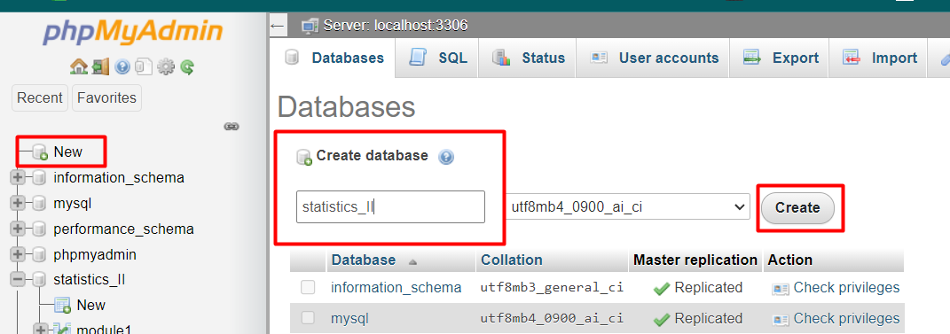
- Navigate to the new database
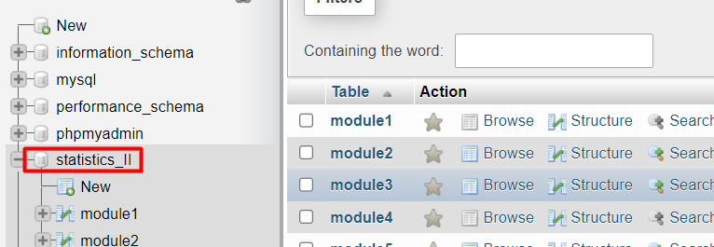
- Navigate to the SQL tab
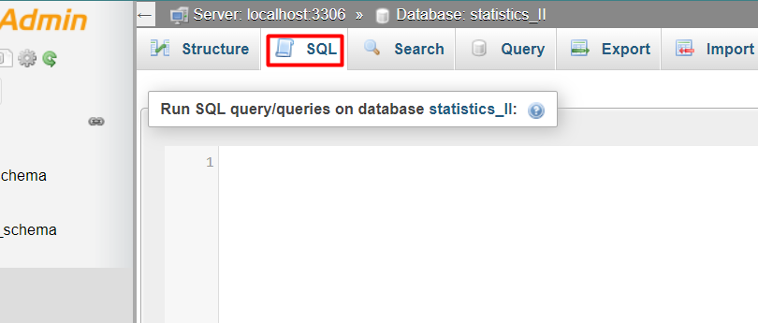

Enter the following code to create tables in the database. Change module1 to the correct module number (or any other name you would like to have for a table).
CREATE TABLE `module1` (
`user_id` text NOT NULL,
`event` text NOT NULL,
`label` text NOT NULL,
`correct` text NOT NULL,
`question` text NOT NULL,
`answer` text NOT NULL
) ENGINE=InnoDB DEFAULT CHARSET=utf8mb4;

- Select Go at the bottom to run the code and repeat as needed for more tables.
- The tables should now appear here
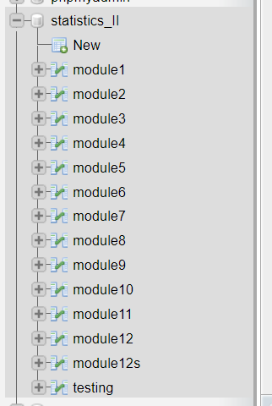

RMarkdown Code to Connect to the Database

You will need the following code in the setup chunk:
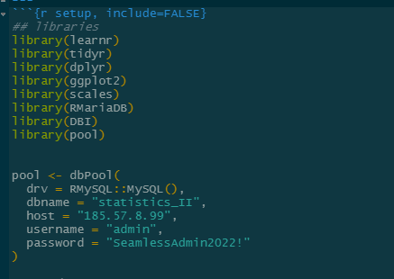
To write to the database, put the following code below the connection code in the setup chunk:
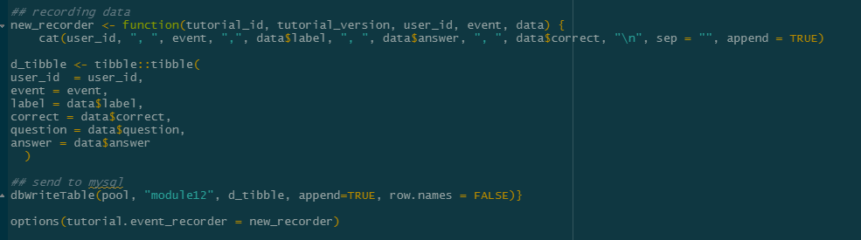
Replace module12 with the relevant module or any other table you’ve set up in the database and wish to use in the Rmd file.
And to read from the database, you can use this in each relevant code chunk:
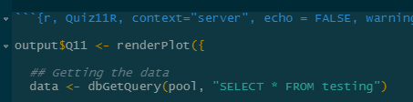
Replace “testing” with the name of your table in the database, usually something like “module1”.

